OT5 Psalms
Dr. Marvin J. Effa

Authorship and Date: While some psalms are anonymous and therefore undated, dates range from Moses to Solomon. The titles to the various psalms relate 73 them to David, two to Solomon, 12 to the sons of Korah (who led the revolt in Numbers 16), 12 to Asaph (an outstanding musician of David’s time), one to Heman (a wise man and a singer, 1 Kings 4:31), one to Ethan (a singer, 1 Chron. 15:19), and one to Moses. The majority of the psalms were written during the times of David and Solomon (tenth century b.c.).
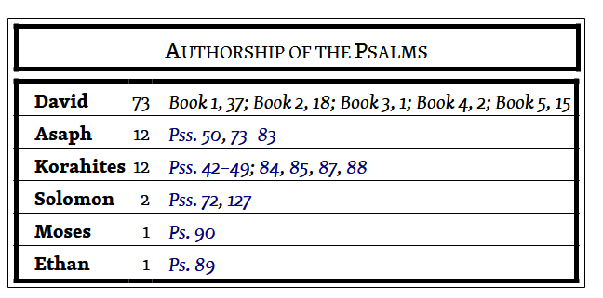
Purpose: Israel’s hymnbook.

Idea: Each psalm has a unique idea, but similar topics do occur:
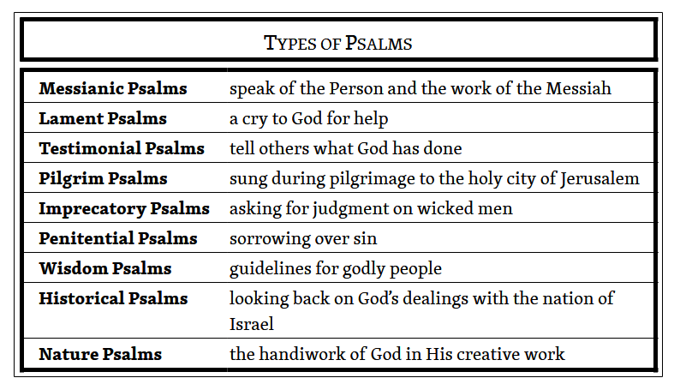 | 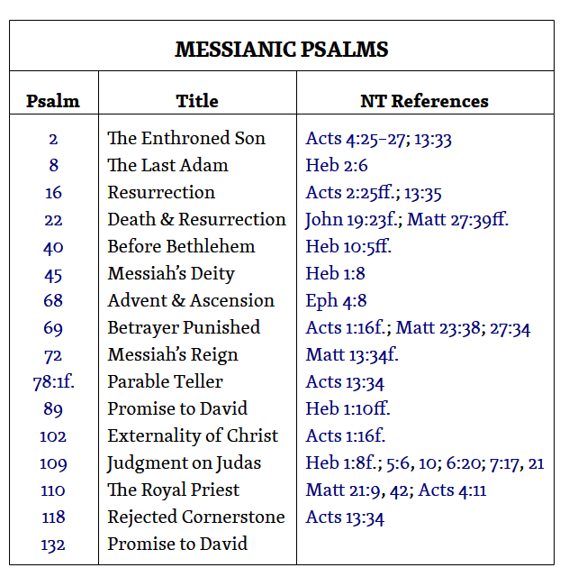

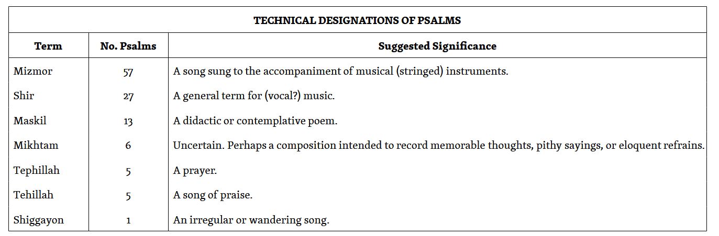

Development: The psalms are divided into five books, each ending with a doxology (1–41; 42–72; 73–89; 90–106; 107–150).
Within the Psalter are subordinate groupings of psalms. At some very early stage these smaller groups may have existed independently, but this is not certain. Attention has already been directed to the psalms of “the sons of Korah” (42–49), Asaph (73–83) and the Davidic groups (Book One; 138–45). Other groups include “the songs of ascents” (120–34), the “hallelujah” psalms (111–18; 146–50), the maskil groups (42–45, 52–55), mikhtam group (56–60), and the hodu psalms (105–7) which all begin with the Hebrew imperative for “give thanks.”

Book | Chapters | Theme | Corresponding Book
Book 1 | 1-41 | Man & Creation | Genesis
Book 2 | 42-72 | Israel & Redemption | Exodus
Book 3 | 73-89 | Temple Worship | Leviticus
Book 4 | 90-106 | Man’s Journey on Earth | Numbers
Book 5 | 107-150 | Word of God | Deuteronomy

Key Passage Exegesis
Psalm 2
Author: David (Acts 4:25).
Idea: Nations must submit to the Messiah’s millennial rule or be destroyed.
Development:
- The nations’ rulers plot to overthrow the Messiah, Psalm 2:1-3.
- The objections to the Messiah are ridiculous, Psalm 2:4-6.
- Having received dominion over the nations, the Messiah will rule ferociously, Psalm 2:7-9.
- Wisdom warrants respect, homage, and faith in the Messiah, Psalm 2:10-12.

Psalm 8
Author: David.
Idea: Mankind’s future role is truly glorious.
Development:
- God’s name will be exalted everywhere on earth, Psalm 8: 1.
- If God can make the heavens, then He can stop His enemies, Psalm 8:2-3.
- He remembers His “mortal band” and shares honor and glory, Psalm 8:4-5.
- He will rule His creation through humans, Psalm 8:6-9.

Psalm 16
Author: David.
Idea: Everyone (men, women, and children) who worships the Lord can live in confidence.
Development:
- A godly group trusts in the Lord, Psalm 16:1-3.
- David has a distain for all other options, Psalm 16:4.
- God’s providence is beautiful, Psalm 16:5-6.
- God’s oversight deserves our praise, Psalm 16:7.
- Focus on the Lord and don’t fear, Psalm 16:8-11.

Psalm 23
Author: David.
Idea: The Lord leads and provides for all who believe.
- God will lead you, Psalm 23:1-4.
- God will provide for you, Psalm 23:5-6.

Psalm 45
Author: Sons of Korah.
Idea: There are great advantages to dwelling with the king.
- This is a good topic, Psalm 45:1.
- Our king is an awesome warrior, Psalm 45:2-5.
- Our King is preferred, Psalm 45:6-9.
  - His rule is eternal, Psalm 45:6a.
  - His rule is righteous, Psalm 45:6b.
  - He is better than his companions, Psalm 45:7.
  - His garments and home are amazing, Psalm 45:8.
  - His women are highly regarded, Psalm 45:9.
- Stop looking back: your future is with the king, Psalm 45:10-12.
- Come dwell with the king, Psalm 45:13-15.
- His rule will be global, Psalm 45:16-17.

Psalm 110
Author: David.
Idea: David’s Son will rule the world.

Development:
- David’s Son will rule over his enemies, Psalm 110:1-2.
- The Mosaic Law would be replaced by a new eternal order, Psalm 110:3-4.
- David’s Son will return a second time and conquer the world, Psalm 110:5-7.

Psalm 110: A Messianic Panoply
A written summary of Psalm 110

One of the most quoted psalms in the New Testament, this psalm provides an overview of the Messiah’s future, triumphant victory over His enemies. King David is given an oracle/revelation from God the Father regarding David’s Lord, Jesus. David’s Lord is both his God and his descendent. Jesus used this psalm to confound His enemies (Matthew 22:41-46. The difficult question is left unanswered, “If the Messiah is the son of David, why does David call him ‘my Lord’?” No father would call his own son “Lord.”).

At His first coming, the Messiah created many enemies. He then returned to His Father, who instructed Him to wait for a while; the unresolved problem of the rejection of the Messiah’s amazing and sacrificial work will be resolved by the Father who will subdue all of the Son’s enemies, verse 1.

In verse 2 we find that the Father will send out the strength of the Messiah from Jerusalem with the command to rule over His enemies…even those in the midst of Israel. The scepter or branch of verse 2 refers to a king governing his subjects.

When the Messiah comes in His majestic, mighty holiness He will finally find his people, the Jews, willingly available (like a free-will offering), verse 3. While the last part of verse 3 is difficult to understand, it may refer to the Messiah after His crucifixion. What sort of condition will He be in after his death? “From the uterus of the early morning light, to you the dew of your youth” ends verse 3. Perhaps this is a visual statement that the dark gloom of the sepulcher gives birth to the vibrant eternal youth needed for the victory at hand.

The Mosaic system virtually worshiped by Messiah’s enemies will be ended, verse 4. The king/priest Melchizedek stands in contrast to the Aaronic and Levitical priesthood. The Messiah is from David’s lineage, the tribe of Judah. David’s son could never be a priest, but the Father determined a new standard would be set for David’s Lord—one that follows Melchizedek and not Abraham, Levi, or Aaron. This is a non-negotiable, eternal decision that is not up for review.

The graphic implementation of the Messiah’s obedience to the Father’s sending out of the Messiah (verse 2) follows in verses 5 and 6. What does this king/priest do? David’s Lord, at the right hand of the Father, angrily shatters (literally pierces and strikes through) the ruling kings (verse 4). He judges the gentile nations (remember, the Messiah’s people have willing given themselves to Him, verse 3). The result of this angry judgment is massive casualties—corpses everywhere! The Feast of the Birds described in Revelation 19 provides a graphic description of this violent judgement. The annoying problem of a particular king is also addressed in verse 6. In verse 5 “kings” is plural, but “chief” in verse 6 is singular. The change from plural to singular is not reflected in the translations. The chief of verse 6 is described as one who rules most of the earth. Antichrist does indeed conquer most of the earth, but fails to secure the regions south and west of the Dead Sea. Although victorious over much of the earth, Antichrist meets the same fate as the other gentile kings: he is pierced through.

Having won His victories, the Messiah immediately begins restoration of the earth and pauses for a refreshing drink from a brook along the road. Sin’s poisonous grasp on Planet Earth begins immediately to loosen upon the death of Antichrist and the Messiah’s millennial arrival. The psalm ends with a simple statement that the Father (the subject of the causative Hebrew stem) will cause Messiah’s head to be exalted. This priest/king of David’s lineage will forever be the Priest/King ruling with His willing people, first on this earth and then continuing into eternity.

In summary, we can see a number of important aspects about David’s Lord:
- He is a descendant of King David
- He has a unique relationship with the Father
- He will be rejected by His people
- He will ascend into Heaven and sit by the Father
- He will return to Heaven for a period of time
- He will bring an end to the Mosaic law
- He will return at a time when His people believe in Him
- He will destroy the gentile kings of the earth
- He will destroy the Antichrist
- He will reign victoriously on this earth and His reign will be forever.

Given this overview of the future, people are invited to believe in the Messiah. He came the first time to pay for the sins of the world and to rise from the dead. When He returns He will come as the sovereign king/priest angrily subduing the enemies. By believing in Him now, we are arriving in faith ahead of His people, the Jews, who will only believe in Him shortly before His return. Secure your place in the Messiah’s future kingdom by believing in Him today.

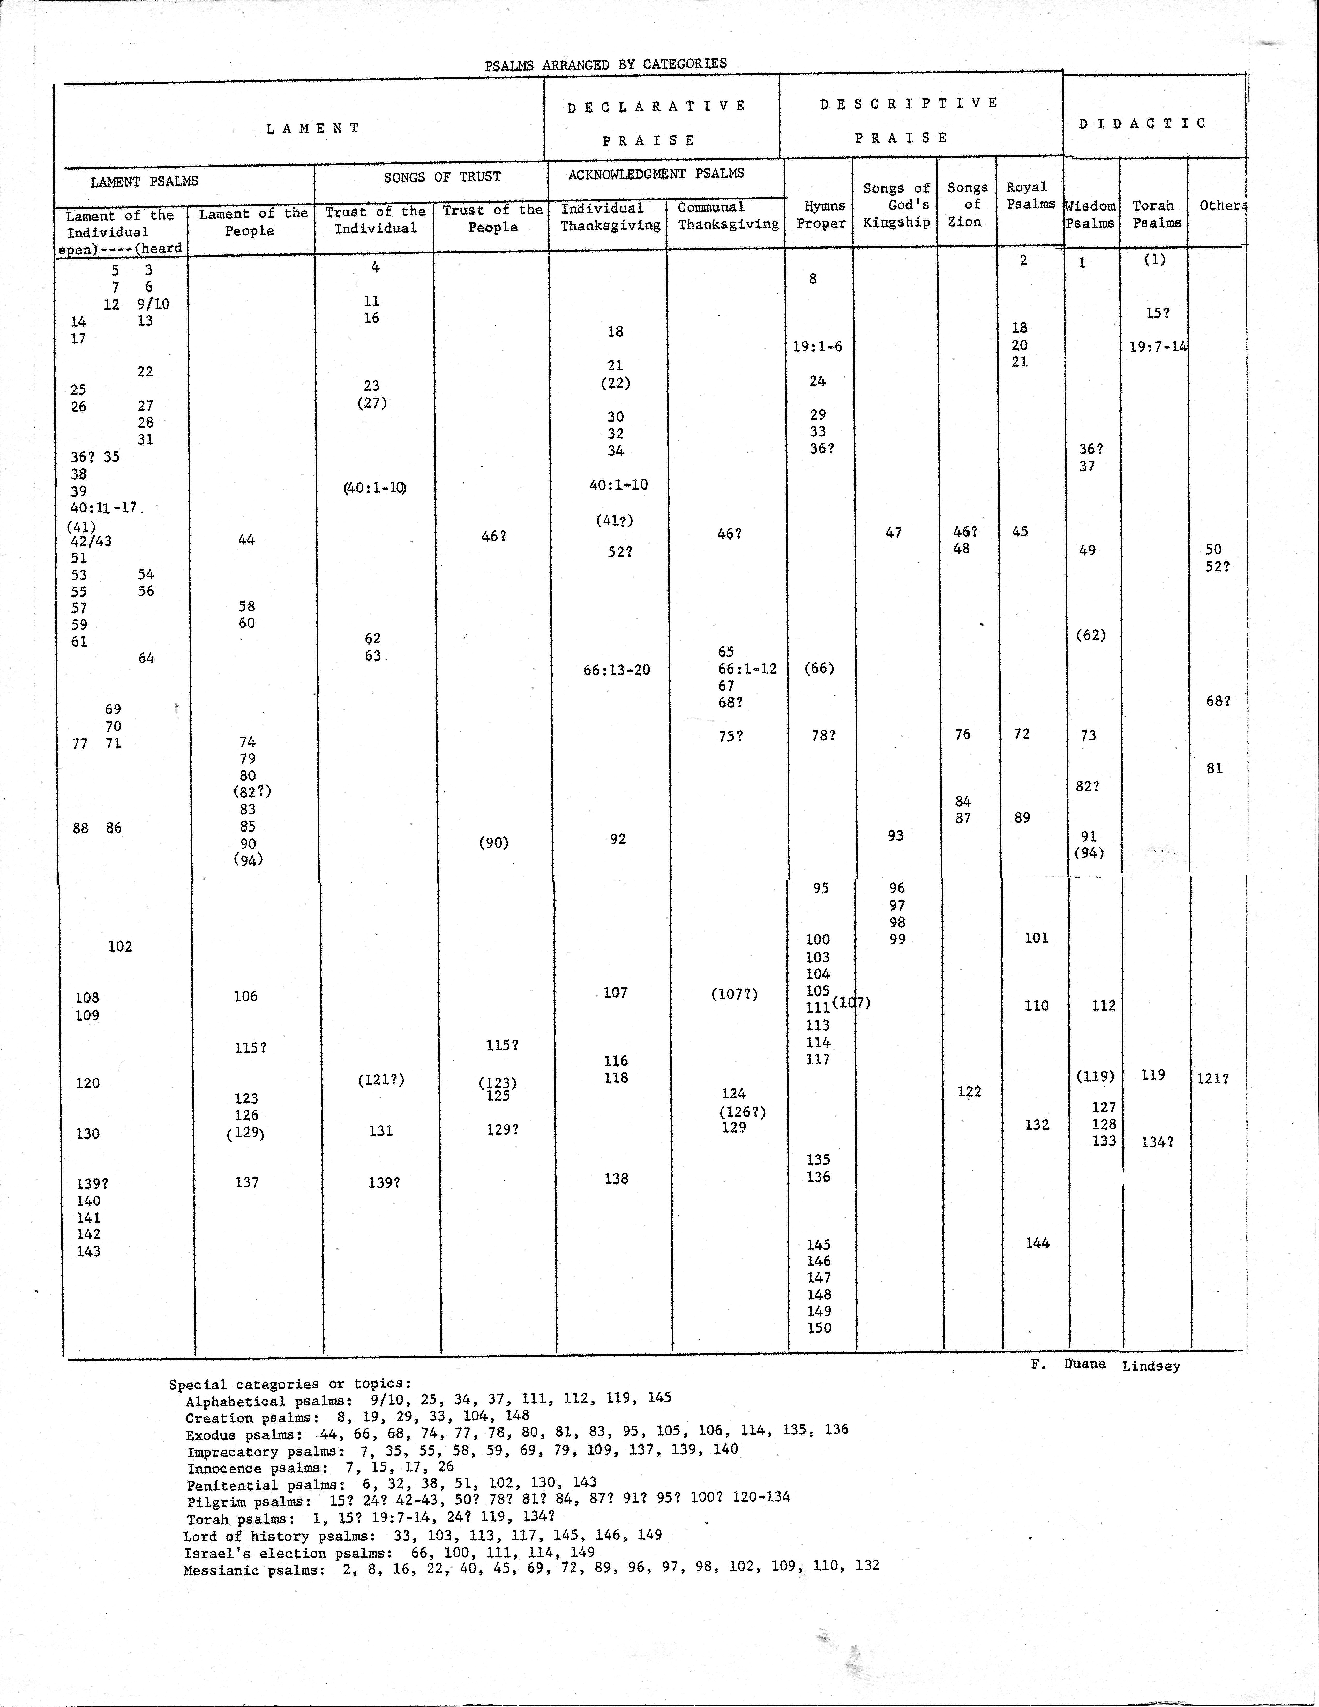

Ryrie, C. C. (1994). Ryrie study Bible: King James Version (Expanded ed., p. 831). Chicago: Moody Press.
Smith, J. E. (1996). The wisdom literature and Psalms (Ps). Joplin, MO: College Press Pub. Co.

